Press release 3-2016

the 6th of June 2016

**GiPA is starting its PAD programme in Iran**

In Vienna, on the 14th of July 2015, an agreement has been found regarding Iranian nuclear programme. With the sanctions relief towards Iran included in the deal, many automotive players consider Iran as an important growth trigger for the aftersales players.

The country characteristics are appealing: Iranian population is beyond 80,000,000 inhabitants (65% is 20 years old or older), its passenger car parc is estimated to be around 12,000,000 and local production in 2015 almost reached 900,000 vehicles.

Therefore Iranian market attracts the interest of foreign automotive industry. Vehicle and part manufacturers, lubricant and tyre specialists want to be involved in Iran who aim to become a regional and even international leader.

Nevertheless from foreign automotive industry, Iranian market is quite unknown: its trade openness is very recent and market data are almost inexistent.

**In order to fill this need, GiPA is running for the 1st time its PAD programme (Panorama Aftersales Data) in Iran.**

PAD is a package of two quantitative surveys. A driver survey designed according to quota methodology based on drivers population will be carried out. It will enable to understand:

* Iranian passenger car parc
* Passenger car parc usage
* Aftersales behaviour
* Drivers expectations
* Way of carrying out maintenance (do-it-yourself, buy & fit, do-it-for-me)
* Workshop entry description (motivation, volume, value…)
* Market share of repair channel
* Drivers satisfaction
* …

A second survey will be carried out among service providers and buying channels in order to understand channel per channel:

* Professional characteristics
* Business organisation in terms of logistic and commercial behaviour
* Expectation from suppliers
* Future of their business
* …

A combined analysis of these two survey will enable to quantify :

* Parts market potential (tyres, lubricant and fast moving parts…)
* Channels market shares (retail and/ or fit)
* Channels market shares according to the car profile (age, engine…)
* Distribution flow f specific product
* …

Results of the study will be available during the second semester of 2016.

For further information, please contact the project manager for Iran within GiPA:

Quentin Le Hetet

Business development  
+44 77 60 56 58 74  
[qlehetet@gipa.eu](mailto:qlehetet@gipa.eu)

**GiPA presence**

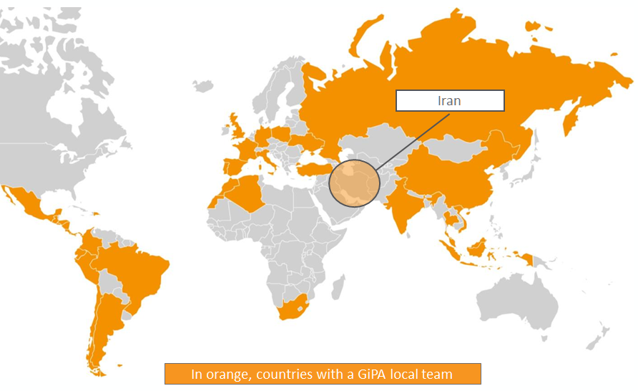

For any question regarding GiPA Group and its strategy, please contact GiPA Group CEO:

Eric Devos

CEO GiPA Group  
+33 1 53 04 08 50  
+33 6 07 63 63 18  
[edevos@gipa.eu](mailto:edevos@gipa.eu)